BITS PILANI, DUBAI CAMPUS

DUBAI INTERNATIONAL ACADEMIC CITY, DUBAI

**FIRST SEMESTER 2024 – 2025 COURSE:** F213 (Object Oriented Programming)

**COMPONENT:** Lab 11 **DATE:** 13th November 2024

Q.1.

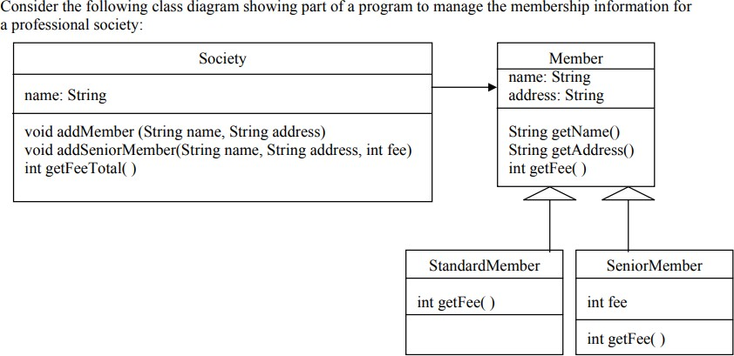

Class Member is an abstract class. Class Society contains an array list which stores details of all members (both Standard Member and Senior Member). Society also has a method which calculates the total fee of all members stored in the array list.

* 1. Write a Java program to create an interface Paint with a method color() that takes no arguments and returns void. Create three classes Red, Green, Blue that implement the Paint interface and override the color() method to print their respective colors.
  2. Write a Java program to create an interface Searching with a method findkey() that finds a key in an array of integers. Create two classes LinearSearch and BinarySearch that implement the Searching interface and provide their own implementations of the findkey() method.